॥ Jai Srimannarayana ॥
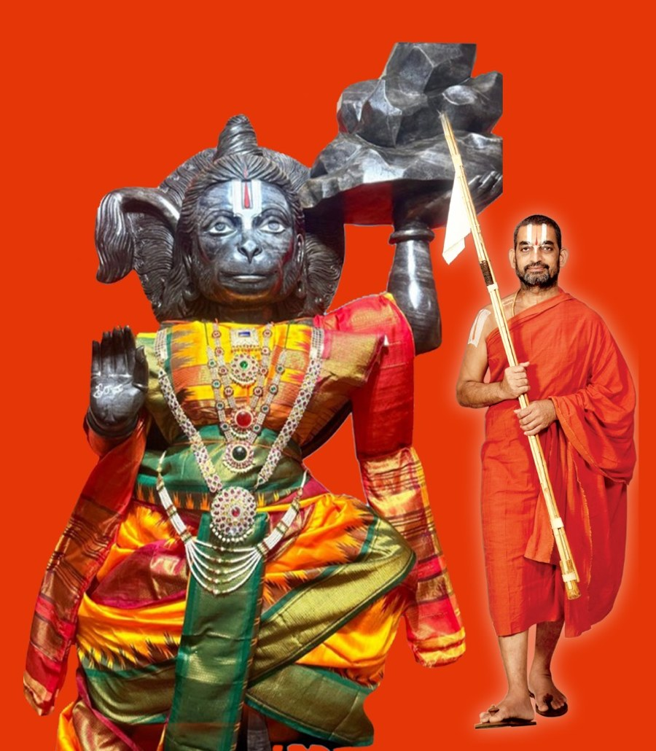
Sri: Hanuma:n Pra:na Prathishtta
श्री हनुमान प्राणप्रतिष्ठा · శ్రీ హనుమాన్ ప్రాణప్రతిష్ఠ
November 13–17, 2026
Sanjeevani Jeeyar A:sramam · 494 Beverly Rancocas Rd, Willingboro, NJ 08046
In the divine presence of HH Sri: Tridandi Chinna Jeeyar Swa:mi:ji — his 70th Thirunakshathram year
Free and open to every family · register at jetnj.org · all times US Eastern

The Five Sacred Days — At a Glance
1. Friday, November 13 — Program Start · Vishvakse:na Pu:ja · Ankura:rpanam (Evening · 6:00 – 9:00 PM)
2. Saturday, November 14 — Ya:gasa:la Ho:mas · HH Swa:mi:ji Arrival · Jala:dhiva:sam (8:00 AM – 9:00 PM)
3. Sunday, November 15 — A:cha:rya Thirunakshathram · 1,008 Food Kits Seva (8:00 AM – 9:00 PM)
4. Monday, November 16 — Pra:na Prathishtta & Kumbha Pro:kshana by HH Jeeyar Swa:mi:ji (7:00 AM – 9:00 PM · muhu:rtham 9:30 AM)
5. Tuesday, November 17 — Vadama:la Se:va · Aakupu:ja · Concluding Mangalam (8:00 AM – 9:00 PM)
All five days — open darshan & Mahaprasa:dam · traditional attire requested. Sanjeevani Hanuma:n Di:ksha: November 8–16.

Day 1 · Friday, November 13
Program Start · Vishvakse:na Pu:ja · Ankura:rpanam · Evening · 6:00 – 9:00 PM
6:00 – 8:00 PM — Sri: Vishnu Sahasrana:ma (SVSN) pa:ra:yanam, Bhagavath pra:rthana, Vishvakse:na pu:ja & Punya:hava:chanam, Raksha: bandhanam
8:00 – 9:00 PM — Mrith-samgrahana & Ankura:rpanam (sprouting rites), Thi:rtha prasa:da goshti

Day 2 · Saturday, November 14
Ya:gasa:la Ho:mas · HH Swa:mi:ji Arrival · Jala:dhiva:sam · 8:00 AM – 9:00 PM
8:00 AM – 8:00 PM — Hanuma:n Cha:li:sa & Hare Ra:ma manthram pa:ra:yanam
✦ Devotees join in batches
8:00 – 10:30 AM — Se:va:ka:lam, Pra:thah-ka:la ya:gasa:la ho:ma a:rambham, Cha:thustha:na archana & special ho:mas
✦ Receive kankanams from the priests & join the sankalpam
12:00 PM — Nithya pu:rna:huthi, Thi:rtha prasa:da goshti & Swa:mi:ji swa:gatham prep
12:00 – 2:00 PM — Ko:la:tam, Garba & HH invitation
✦ All devotees participate
2:00 – 3:00 PM — ★ HH Swa:mi:ji arrival (around 2 PM) ★
✦ Ko:la:tam welcome
4:30 – 5:30 PM — Ra:ga:njali — a heartful rendering on the greatness of the A:cha:rya
✦ Devotees from all over are invited to join
5:30 – 8:00 PM — SVSN pa:ra:yanam, Chathushta:na archana & special ho:mas
6:00 – 8:00 PM — VT SEVA annual event: Vasantham
8:00 – 9:00 PM — Jala:dhiva:sam, Nithya pu:rna:huthi & Thi:rtha prasa:da goshti, Maha: prasa:d
✦ Devotees invited to offer thi:rtham to all mu:rthis

Day 3 · Sunday, November 15
A:cha:rya Thirunakshathram · 1,008 Food Kits Seva · 8:00 AM – 9:00 PM
8:00 AM – 8:00 PM — Hanuma:n Cha:li:sa & Hare Ra:ma manthram pa:ra:yanam
✦ Devotees join in batches
8:00 – 10:30 AM — Se:va:ka:lam, Pra:thah-ka:la ya:gasa:la ho:mam, Chathustha:na archana & special ho:mas
10:00 AM — Mruthika Snapanam — Abhishekam to all Mu:rthis
✦ Abhisheka darshan for all devotees
12:00 PM — Nithya pu:rna:huthi, Thi:rtha prasa:da goshti
2:00 PM — 1,008 Food Kit Distribution Seva & Maha: nive:dana
✦ Local citizens will be invited
4:30 PM — Thirunakshathra Maho:thsavam — Sa:mu:hika Gala:rchana
✦ All devotees participate
5:30 PM — Video highlights & presentations — centers, JET USA & VT SEVA leaders
6:00 PM — Marya:da:s from organizations, leaders, temples & dignitaries
6:30 PM — HH Sri: Swa:mi:ji Anugraha Bha:shanam
7:30 PM — A:cha:rya Sri: Pa:da Pu:ja
✦ All devotees participate
8:00 PM — 70 offerings to His Holiness
✦ All devotees participate
6:00 – 9:00 PM — SVSN pa:ra:yana, Chathustha:na archana, Dha:nya:dhiva:sam, Phala-pushpa shayya:dhiva:sam & Nithya pu:rna:huthi, Thi:rtha prasa:da goshti
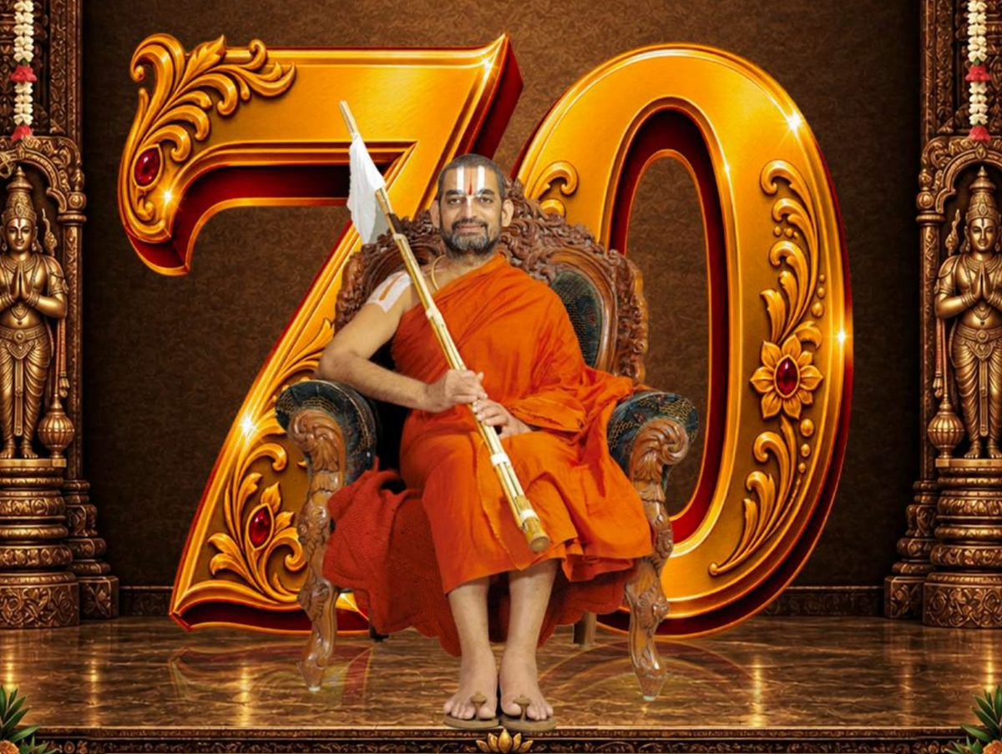
Yatindra Saptati — 70 Years of Seva: the global goshti celebrates the 70th Thirunakshathram of HH Sri: Tridandi Chinna Jeeyar Swa:mi:ji — in his own divine presence, amidst the Pra:na Prathishtta of Sri: Hanuma:n.

Day 4 · Monday, November 16
Pra:na Prathishtta & Kumbha Pro:kshana by HH Jeeyar Swa:mi:ji · 7:00 AM – 9:00 PM · muhu:rtham 9:30 AM
7:00 – 9:00 AM — Se:va:ka:lam, Pra:thah-ka:la ya:gasa:la ho:mam, Chathushta:na archana & special ho:mas, Maha: pu:rna:huti & Kalasa udva:sana rites
9:30 – 10:30 AM — ★ SRI: SANJEEVANI HANUMA:N MAHA: PRA:NA PRATHISHTTA & KUMBHA PRO:KSHANA BY HH JEEYAR SWA:MI:JI ★
✦ Receive pro:kshana thi:rtham sprinkles with devotion
10:30 AM – 1:30 PM — Prathama a:ra:dhana, Sa:nthi Kalya:nam — Sri:niva:sa Kalya:nam, Si:tha-Ra:ma Kalya:nam — & Nive:dana
✦ Invite all
1:30 PM — Thi:rtha prasa:da goshti, A:si:rva:chanam & A:cha:rya felicitation
5:30 PM — Sri: Vishnu Sahasrana:ma pa:ra:yanam
6:00 – 8:00 PM — ★ SRI: SI:THA-RA:MA KALYA:NAM & PALLAKI SE:VA TO SRI: SANJEEVANI HANUMA:N ★
✦ Offer akshata at the mangalya dha:rana; join the procession
8:00 PM — Thi:rtha prasa:da goshti, Maha: prasa:d
✦ Festive Mahaprasa:d dinner; receive blessed thi:rtham

Day 5 · Tuesday, November 17
Vadama:la Se:va · Aakupu:ja · Concluding Mangalam · 8:00 AM – 9:00 PM
8:00 – 10:30 AM — Se:va:ka:lam, Pra:thah-ka:la a:ra:dhana
11:30 AM — Thi:rtha prasa:da goshti
✦ Receive thi:rtham; community Mahaprasa:dam lunch
6:00 PM — Sri: Vishnu Sahasrana:ma pa:ra:yanam
6:30 – 8:00 PM — Hanuma:n Vadama:la, Betel Leaf Archana (Aakupu:ja Se:va) & Vise:sha Uthsavam
✦ Sponsor vadama:las; chant Hanuma:n Cha:li:sa
8:00 PM — Maha: Ha:rathi, Thi:rtha prasa:da goshti & Concluding Mangalam
✦ Receive thi:rtham and blessed vadama:la boxes
8:30 PM — Volunteer appreciation

Seva Sponsorships
Sanjeevani Legacy Circle — $9,999
One-time pledge · the complete Mahotsavam · Pagadi Utsav — special Pallaki Se:va honors
Full Program — All 5 Days, All Events — $1,512
Includes the Si:tha-Ra:ma Kalya:nam with Vigrahams for your family
One Day Sponsorship — $504 / day
Sponsor a full day of the mahotsavam · sponsor 1–5 days
Sri: Si:tha-Ra:ma Kalya:nam — $252
The divine wedding & Pallaki Se:va evening · Mon, Nov 16 · 6 PM
Prathama Archana after the Pra:na Prathishtta — $108
The first archana, in your family's name · Mon, Nov 16
Daily Offerings — $54 / day
Flowers & Annada:nam (Thadi:ya A:ra:dhana) — any day(s), 1–5 · Vadama:la & A:ku Pu:ja — Tuesday, November 17
Every seva is offered in your family's name · jetnj.org → Sponsor. Attendance is free regardless.

One Global Family — Global Peace & Prosperity
jetnj.org · Sanjeevani Jeeyar A:sramam · 494 Beverly Rancocas Rd, Willingboro, NJ 08046 · +1 (856) 221-2172

